SWAMPED !

The devastating impact of the July 2007 floods
on Britain’s nuclear weapons factories

Nuclear Information Service
September 2008



www.nuclearinfo.org
office@nuclearinfo.org

“We need to be more willing to tell people the truth about risk. The current lack of clarity and transparency has the potential to put not only people’s homes, but lives in jeopardy.” ¹

- Sir Michael Pitt, Chair of the Independent Review into the floods of 2007.

Introduction

Over the spring and summer of 2008 the Ministry of Defence, the Health and Safety Executive, and the Environment Agency provided the Nuclear Information Service (NIS) with copies of a number of documents relating to serious flooding which had occurred at the Atomic Weapons Establishment (AWE) Burghfield in July 2007 in response to requests made under the Freedom of Information Act.

Following the flooding, the AWE Executive Board commissioned an investigation into the impact that the event had had on the Aldermaston and Burghfield sites. The investigating team published a 78 page report with 43 recommendations - ‘Review Learn and Improve Assessment of Extreme Weather Events on AWE Sites (Flooding)’ - in November 2007. A copy of Review, Learn, and Improve Assessment was released to NIS following our request for information, along with material from Safety Case documents and Site Inspection Reports for AWE Burghfield, and together they provide the source material on which this report is based.

The documents provide an alarming insight into the severity of the flooding and raise serious questions about the adequacy of AWE’s emergency response to the incident and the company’s forward planning for dealing with flood events. They also show that the company considered it prudent to limit the disclosure of information about the impact of the flooding in order to protect its reputation, rather than tell local stakeholders and the public about the true extent of the crisis that had arisen.

This NIS briefing provides a brief summary and commentary on some of the key points which emerge from the documents. We also make a number of recommendations which aim to increase standards of transparency and public scrutiny of arrangements for the prevention and management of flooding or similar crises at AWE.

The flood events of 20th July 2007 and AWE’s response

The summer of 2007 was the wettest summer recorded since 1912 in England and Wales. On 20th July 2007 torrential rainfall fell in the West Berkshire area, along with many other areas of the country, and West Berkshire Council and Thames Valley Police activated their emergency plans to deal with the serious flooding which resulted.

The heavy rainfall resulted in some areas of the AWE Aldermaston and AWE Burghfield sites, both located in West Berkshire, being subjected to severe flooding.

At Aldermaston, the North Ponds Water Management System, designed to deal with surface water runoff from the site, came very close to being overwhelmed and was just 1-2 hours away from failure. This could have resulted in the release of potentially contaminated surface water runoff from the site into the Aldermaston Stream. The Aldermaston site telephone exchange was also flooded, and was only kept operational as a result of prompt action by AWE’s on-site Fire and Rescue Service. Despite these problems, operations at the Aldermaston site, which is on relatively high ground, were not disrupted over the long term and the site was able to recover quickly from the flooding.

The situation at the Burghfield site was far more serious. AWE Burghfield is situated on low lying land within the flood plain of the River Kennet, and the Burghfield Brook, which once flowed across the site, has been diverted around the edge of the establishment. Large parts of the site are shown as being at risk of flooding on flood maps published by the Environment Agency (see Figure 1).

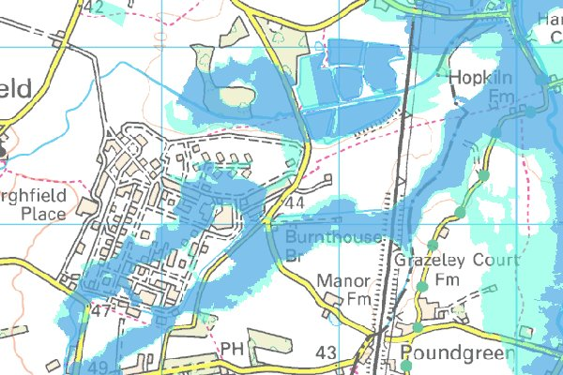

Figure 1. Flood map for AWE Burghfield. Shaded areas represent areas at significant risk of flooding, where the chance of flooding each year is greater than 1.3% (1 in 75).

The AWE Review, Learn, and Improve Assessment concluded that “the AWE (B) site experienced significant ground flooding throughout substantial areas of the site, which had an immediate impact

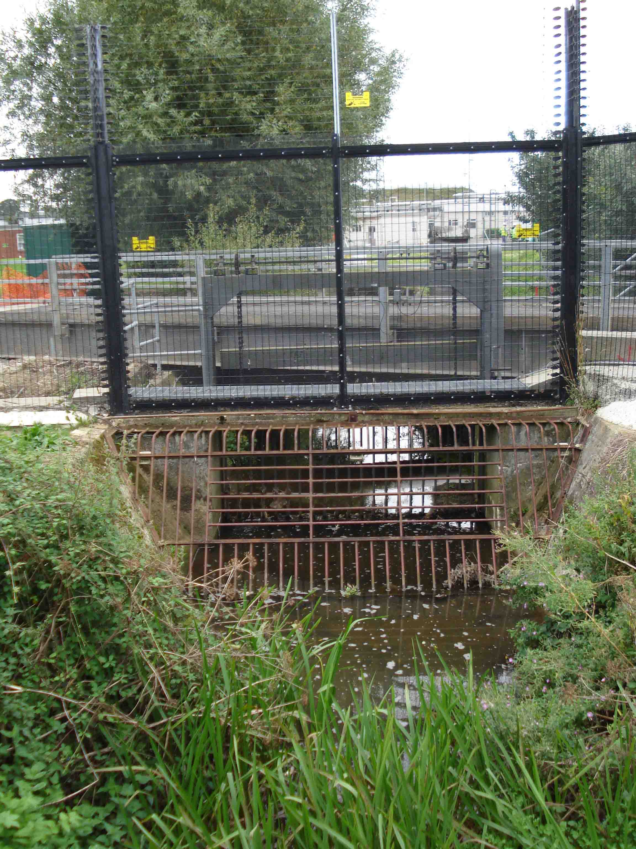

Figure 2. The Burghfield Brook emerges from under the security fence on the Eastern perimeter of the AWE Burghfield site. On 20th July 2007 flood water from the brook, which flows around the edge of the site, overwhelmed buildings in the nuclear licensed site at AWE Burghfield.

on site facilities and resulted in longer-term disruption”. By mid afternoon serious flooding had affected the nuclear licensed site area of the factory, which includes the warhead assembly area; the explosives area; and other parts of the site. In total 84 buildings on the Burghfield site were affected by the flooding, and virtually every facility within the nuclear licensed site area experienced floodwater ingress, causing widespread damage to infrastructure.

As the flood waters rose the force of the water was powerful enough to lift drain covers in some parts of the site and carry a number of heavy thermal jackets, each weighing over 30 kg, a couple of hundred yards across the site. The water level reached a height of over two feet - completely cutting off one facility on the site – and triggering multiple alarms across the site as it rose.

Power to the warhead assembly area was switched off by AWE personnel to prevent an accident, and eventually electricity to virtually the whole of the site had to be shut down, leaving criticality alarms and fire alarms disabled. The Burghfield site Fire and Rescue Service and site Safety Shift teams were deployed to defend buildings, clear water, and recover moveable assets, but in one part of the site were overcome by the volume of water. Fortunately, three members of AWE Aldermaston safety personnel happened by chance to be visiting Burghfield and were able to assist with the response, but even so one key facility came close to being overwhelmed by the flood waters.

AWE Burghfield normally closes for the weekend at noon on Friday, and so most staff had already left the site before the height of the flood. Within the warhead assembly area the majority of radioactive material had been removed from processing facilities and returned to storage. The consequences of the flood might have been even more serious had the site been under normal operating conditions with radioactive material in use in the assembly area. Under certain circumstances, water can act as a neutron reflector and the risk of a criticality accident increases if radioactive materials are immersed or submerged. Contact between floodwater and radioactive material could have resulted in radioactive contamination of buildings and their contents and possibly given rise to a criticality incident. The Safety Case for the AWE Burghfield Assembly Facility indicates that “the accidental introduction of moderator / reflector such as oil or water to a criticality station, including full or partial flooding” is a credible means of initiating a criticality event in the facility.

Fortunately, as the site had closed down for the end of the working week, most of the fissile material on site had been placed in storage and so the risk of a criticality accident caused by the flooding did not arise. Nevertheless, material from the radioactive inventory had to be recovered from two flooded buildings in the nuclear licensed site area, posing substantial challenges in recovering the material and decontaminating the buildings.
Immediate aftermath of the flooding

As the situation deteriorated AWE took the decision to progressively close down the buildings most affected in a controlled manner, but despite the severity of the flooding a Site Emergency was not formally declared at either Aldermaston or Burghfield. AWE’s Review, Learn, and Improve report concluded that “it was not clear that site personnel understood the site status and who was in charge”.

At around 18.00 on Friday 20th July the flood waters began to recede at Burghfield. Over the weekend, in the immediate aftermath of the flood, assessments of damage and the situation on the site began, but were delayed because key personnel (including company leadership, facility managers, and suppliers) were not on site. There was no expectation that key staff would attend the site over the weekend; no plans existed for contacting key staff; and personal contact details were not always available.

Site regulators and the local authority were not informed of the problems at Burghfield until well after the incident. Although robust arrangements are in place for informing regulators about incidents and emergencies, these were not used. The Environment Agency’s Nuclear Regulation Group were not informed of the flooding until the evening of Sunday 22nd July – 48 hours after the flood waters had receded - and West Berkshire Council’s Emergency Planning team did not learn of the problems until well after the event.

Clean up and recovery

The flooding resulted in severe disruption to operations at AWE Burghfield, and live nuclear working at the site was suspended for nine months while repair work and recommissioning was underway. AWE plc was advised by the Health and Safety Executive that “it should complete recovery operations, including satisfying us that the emergency arrangements meet the standards laid out in the site emergency plan, before contemplating attempting to resume operational activities”.

Ten days after the flood, two inches of water was still remaining in some areas, and fire alarm systems were not fully reinstated until some 14 days after the floods. Even after the system had been repaired condensation in fire detection panels caused a risk of false alarms, and so a fire patrol rota was necessary to keep watch over vulnerable buildings .

Recovery of radioactive materials from two buildings which had flooded was the priority during recovery operations, but even so, it took until three weeks after the flood for this task to be completed. Clean-up work was hindered by a lack of suitable equipment (gloves, clothes, Wellington boots, and pumps) and because of damage to accommodation staff were required to work in overcrowded conditions with limited facilities. A large number of documents were destroyed by the flood.

The emergency arrangements infrastructure at Burghfield was particularly heavily affected by the flooding, and the fallback incident control room, fallback medical centre and health physics support areas all sustained some damage. Engineering inspections were necessary for all buildings which had been flooded. Permission to resume routine operations at Burghfield was withheld by the Health and Safety Executive until safety systems, alarms, and telephones had been recommissioned and tested and revised emergency arrangements had been witnessed.

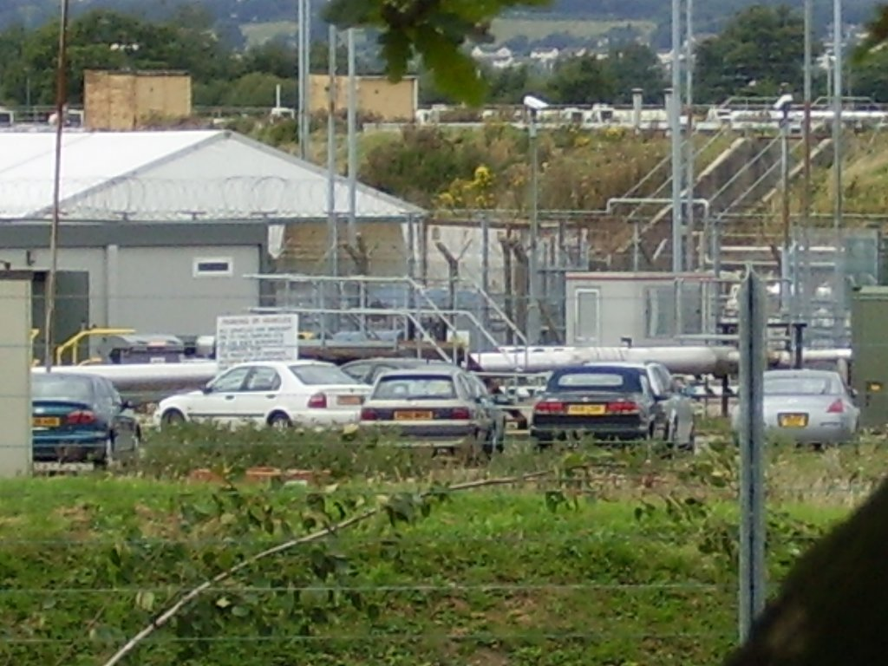

Figure 3. Tents and temporary portacabin accommodation in the car park adjacent to the nuclear licensed site area at AWE Burghfield, August 2007. The tents were used to process, inspect, and clean items from flooded buildings, using radiological protection contamination control principles to segregate ‘clean’ and ‘dirty’ items.

As yet the cost of the flooding to AWE plc has not yet been identified. The cost of the 1989 flood event at Aldermaston was estimated as £16 million, and the authors of the Review, Learn, and Improve Assessment report judge that AWE Burghfield “is likely to incur considerable expense in regaining operational status’.

As well as halting live nuclear work at AWE the flooding also delayed remedial work aimed at improving a number of safety shortfalls identified through the Periodic Review of Safety that was underway at Burghfield at the Health and Safety Executive’s insistence.

Public Information

AWE’s media response to the crisis appears to have been directed more by the desire to preserve the company’s reputation than give an honest account of events to the public. AWE’s corporate management were already sensitive about flooding issues in the aftermath of an event in 1989 when radioactively contaminated surface water escaped from the site and contaminated adjacent premises at Aldermaston Court. The Review, Learn, and Improve Assessment report notes that “the event of 1989 received wide spread media coverage following a prosecution, which resulted in a substantial fine and costs. Media coverage of corporate prosecutions undoubtedly influences a corporate body’s reputation”.

No effort was therefore made to inform the public or local authorities of the scale of disruption caused by the flood. The company took the view that “it was a prudent step to limit the disclosure of information surrounding the degree of impact suffered – particularly at Burghfield” The flooding was briefly mentioned at the September 2007 meeting of the AWE Local Liaison Committee as part of the routine report given by the AWE Director of Infrastructure, but committee members were merely told that a review, learn, and improve assessment would take place and assured that no injuries or releases or radioactive or noxious materials had occurred.

Not surprisingly, given the decision by AWE to limit the release of information about the flooding, the Review, Learn, and Improve Assessment report concluded that there was “little public or media interest in the AWE sites resulting from the 2007 storm event”. Handwritten comments from a regulator in the margins of the copy of the Review, Learn, and Improve Assessment report provided to NIS give a very different view, pointing out that there was significant interest from local people, Greenpeace, media, the Local Liaison Committee, NIS and the Nuclear Awareness Group (NAG).

A public statement on the flooding was eventually forced out of AWE in May 2008 – ten months after the event had occurred - in response to press reports that live nuclear work had ceased at AWE Burghfield. The statement (see Appendix A) did little more than repeat a Ministerial response to a Parliamentary Question on the issue, mentioning “temporary disruption due to flooding” as the cause of the shut-down.

Emergency and Contingency Planning

Previous extreme weather events leading to heavy rainfall have caused problems at both of the AWE sites. As well as the 1989 event which led to the prosecution of AWE, significant flooding had had an impact on operations at Aldermaston during August 1999 and October 2000. The October 2000 event had also affected capability at Burghfield, flooding several buildings in the nuclear licensed site area and “producing a potential pollution incident”.

Given that flooding was a known factor at both AWE sites, it seems reasonable to expect that contingency plans would have been drawn up to deal with similar eventualities in future. However, plans aimed at tackling flood events appear to have overlooked significant practical issues, and action plans aimed at protecting the Burghfield site in particular were neglected, with important actions left uncompleted.

Following the previous flood incidents at Burghfield, a series of ‘Abnormal Event’ actions had been identified by AWE to address areas of concern. The Review, Learn, and Improve Assessment team found that, of nine actions identified to tackle flooding at Burghfield, none had been fully implemented, describing four actions as ‘partially implemented’, two as ‘status unknown’, and three as ‘no action implemented’.

A Utilities Strategic Plan which was developed for AWE Burghfield in 2006 lists a number of deliverables aimed at improving surface water management on the site. Of the 12 deliverables listed in the plan which relate to flooding, seven were listed as outstanding – well over a year behind schedule at the time the Review, Learn, and Improve report was published in November 2007 - and only one was listed as fully completed. Outstanding deliverables included site survey work, development of policy on flood protection, and studies of the hydrogeology of the Burghfield site – all key steps in understanding flood risks at the site.

The Review, Learn, and Improve Assessment also identified a number of shortfalls in emergency planning and Business Continuity planning which became apparent in the aftermath of the floods.

- Risk assessments had apparently not identified severe flooding as a threat to the Aldermaston or Burghfield sites. The Review, Learn, and Improve Assessment team found that: “a review of the risk register data included in the report identified a number of ‘Child’ risk entries relating to flood events. However, these entries all related to discrete individual management areas with no overall ‘Parent’ risk identified for flooding (surface water) of either the AWE (A) or AWE (B) sites. Clearly flooding is a foreseeable event that should be included in an appropriate register along with effective management actions”.

- Emergency arrangements at the two AWE sites allow emergency controllers and responders from one site to provide support to the other site if necessary. The Review, Learn, and Improve Assessment notes that: “it is not clear that the current Site Emergency Plans (both sites) cover flooding on the scale experienced during the event or if site exercises cover such an event”. Risk assessments for emergency situations had apparently not considered a scenario such as widespread flooding with an impact across the district which would prevent one of the AWE sites from supporting the other.

- Key site infrastructure, such as alarm systems and electricity supplies, were out of use during the flooding at Burghfield and its immediate aftermath. The Review, Learn, and Improve Assessment points out that: “site utilities such as electricity supply, telecommunications, drainage, gases etc are all susceptible to a flood event. Extant Safety Cases do not sufficiently assess the multiple failure of all services in this type of extreme event, suffice to say that operations would be suspended and facilities made safe under these circumstances”.

- A large number of Business Continuity (BC) recovery issues were identified during the assessment exercise, and the assessment report concluded: “At present BC planning is in its infancy at AWE and whilst a number of the principles have been applied BC could not have been relied upon at the time of the flooding. Currently no Directorate BC plans have been produced and only corporate level plans exist, covering IT, Telecoms, Crisis Management and Corporate Communication”.

The Review, Learn, and Improve process

The Review, Learn, and Improve Assessment of the impact of the July 2007 floods on AWE Aldermaston was commissioned by the AWE Executive Board to ensure that all aspects of the extreme weather event were thoroughly examined so that lessons could be learnt for dealing with any future flood events. The ten AWE staff who were members of the Review, Learn, and Improve Assessment team have considered a range of issues relevant to AWE’s internal workings, but there is less emphasis on AWE’s relations with local partners and communities. The terms of reference for the assessment state that: “the output from the investigation will be communicated to AWE Management Ltd, the AWE Executive Board, the NWIPT [Nuclear Weapons Integrated Project Team at the Ministry of Defence], and regulatory bodies”, but there is no mention of communicating the findings to the AWE Local Liaison Committee or the public and local media.

West Berkshire Council was not invited to contribute to or share learning through the Review, Learn, and Improve Assessment exercise, even though the Council’s Overview and Scrutiny Commission was at the same time conducting its own special review into the July 2007 floods. The Review, Learn, and Improve Assessment team also seems to have carried out its work without reference to the work of the government’s independent inquiry into the floods, headed by Sir Michael Pitt.

The Terms of Reference for the study state that it should have been concluded by 30th September 2007. In fact, the document was not published until November 2007, and at the beginning of November an inspector from the Health and Safety Executive was still expressing his “disappointment” that the study’s findings had not been issued. The inspector’s report identifies a number of concerns about the Review, Learn, and Improve Assessment process, mentioning that one team “seemed to know very little about the existence of this report, or when it is due to be circulated” and that he had “some concerns that the full implications of the flooding had not yet been fully appreciated” .

Conclusions and recommendations

AWE’s investigation into the flood event concluded that, due to the scale of the event, little more could have been done at the time of the incident to prevent the damage which occurred. A handwritten note by a member of staff at one of the government regulators responsible for AWE makes a more pertinent comment, stating “Little at the time but much I suspect in forward planning!”. Flooding at AWE Burghfield was not an unexpected or even particularly unusual event and AWE managers were aware of the risks posed by flooding, yet actions which had been identified to protect against future floods had been neglected. It is difficult to avoid the conclusion that the impact of the flooding may have been far less severe had the lessons of previous events been heeded.

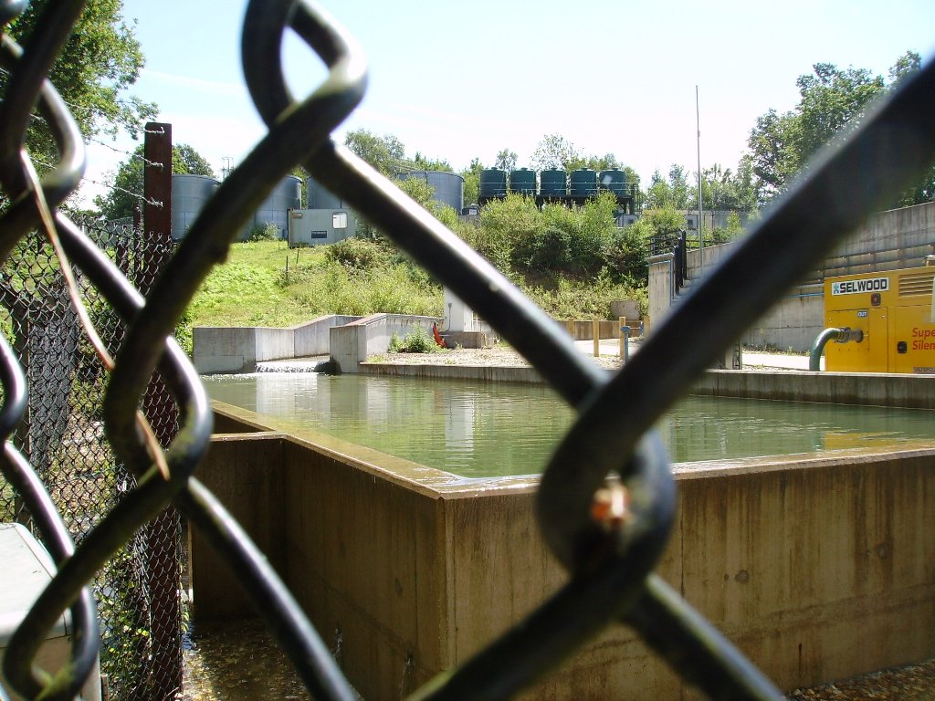

Figure 4. The North Ponds Water Management System at AWE Aldermaston on 21st July 2007 – the day after the floods. Holding tanks in the system are full and water can be seen overtopping the concrete wall of the lower tank and draining away underneath the perimeter fence of the base.

The final comment in the AWE Review, Learn, and Improve assessment report states that: “it should be noted that at no time during the storm event, resultant flooding or initial clean up was there any threat to the nuclear safety of either of the AWE sites, the public or environment.” In the view of NIS, this is a complacent statement which cannot be justified in the light of admissions made elsewhere in the report:

- The North Ponds Water Management System at Aldermaston came “very close to being overwhelmed”, and this “could have resulted in a release of potentially contaminated surface water run-off”.
- As well as the North Ponds, at least two other key facilities “experienced Near Miss events during the storm event”.
- The majority of the Burghfield site was left without power and no functioning alarm systems as a result of the decision to shut down the electricity supply.
- Water ingress into the AWE Aldermaston telephone exchange, which plays a strategic role in emergency response and recovery operations, led to extensive faults with the AWE telephone system.

It is apparent that the storm posed a very real threat to safety and the environment, and that the two sites operated by AWE – both of which are major industrial sites handling radioactive materials and high explosives – experienced serious ‘near miss’ situations.

AWE’s Review, Learn, and Improve Assessment report contains a number of practical recommendations aimed at mitigating against future flooding events. In the light of our observations in this report, NIS would like to propose a number of further recommendations which aim to increase standards of transparency and public scrutiny of arrangements for the prevention and management of flooding at AWE.

- Recommendation 1: The risk of flooding must be a key consideration in the design and management of future projects at AWE Burghfield. The Health and Safety Executive should look carefully at flooding issues as part of its current Periodic Review of Safety at the site, and in particular ensure that new Safety Cases address concerns about the reliability of essential services in the event of flooding and that steps are taken to minimise the likelihood of serious flooding occurring again.

West Berkshire Council and the Environment Agency should take a precautionary approach to flood risk issues when determining planning applications for developments on the AWE Burghfield site. It is likely that future development at Burghfield will need to provide flood protection to a much higher standard than is normally the case, especially for facilities handling nuclear materials. The Review, Learn, and Improve Assessment concludes that: “Current new-build designs consider a 1 in 100 year return period event for non-nuclear facilities and a 1 in 10,000 year return period event for nuclear facilities. As the most recent flood event at AWE (B) is estimated as a 1 in 215 year return period event, it is obvious that the design considerations for non-nuclear facilities could be inadequate to prevent water ingress and damage, although current design considerations for nuclear facilities should be adequate. However, the design considerations should take into account all the utilities and infrastructure serving a high hazard category building and potentially the requirement for such facilities to be self supporting needs to be examined”.

If the likely risks and consequences of flooding cannot be assessed, or if flood protection cannot be guaranteed to the required standard, then permission for new development at AWE Burghfield should not be granted.

- Recommendation 2: Sir Michael Pitt’s independent commission, set up to review lessons learnt from the 2007 floods, has concluded that the government should publish monthly summaries of progress during the recovery phase of major flooding events.

We believe that as good practice this should be repeated at the local level. AWE plc should therefore provide regular updates to site stakeholders on progress with recovery operations in the aftermath of any future emergencies at Aldermaston or Burghfield. This could be done through a series of formal reports to the AWE Local Liaison Committee, which should also be published to a wider audience through local media.

- Recommendation 3: West Berkshire Council’s Overview and Scrutiny Commission, investigating the local impact of the 2007 floods, concluded that actions identified for flood mitigation in individual localities should be subject to public scrutiny. However, the July 2007 flood events raise a number of questions about the effectiveness of arrangements for scrutiny of the operations at AWE through the AWE Local Liaison Committee, given the minimal interest apparently shown by the committee in the consequences of the floods. Had the Local Liaison Committee taken a more investigative approach to its work – for example, by enquiring into why so many actions on action plans drawn up to address flooding concerns remained unaddressed – the impact of the storm on AWE’s operations might have been far less severe.

Membership of the Local Liaison Committee should therefore be strengthened by inclusion of NGO representatives, who could be expected to take a more critical view of AWE’s performance than the local authority representatives who currently make up the committee.

- Recommendation 4: Given that the cost of Britain’s nuclear weapons programme is ultimately paid for by the public, AWE plc and the Ministry of Defence should publish the costs of recovery from the July 2007 floods at AWE Burghfield when a clearer picture of the full extent of the costs is known.

- Recommendation 5: Sir Michael Pitt’s report on lessons learnt from the 2007 floods makes a telling comment in its recommendations on how public authorities have traditionally dealt with issues of risk when issues of security and critical infrastructure are at stake:

“We also need to be more direct with the public about risk. The balance between protecting information about critical infrastructure sites for security reasons and the need to share information with local agencies about such sites to protect them from flooding needs to be rethought. Guarding against one risk can exacerbate the other. As the summer floods showed, actual risk to these sites is much higher than communicated risk, and the public were shocked by the loss of essential services. Responders were poorly prepared, and levels of protection of these key sites did not match the public’s expectations. Critical infrastructure operators and security organisations should be more open about the risks which exist and play a fuller part in civil protection arrangements”.

At AWE, where secrecy has been deeply ingrained in the organisational culture ever since the establishment commenced its work, there is also a need to reconsider how information about risk is communicated to the public. Local residents have a right to open and impartial information, so long as this does not compromise safety and security at the base, and AWE plc and local authorities should therefore be more forthcoming about the nature of the risks which operations at AWE pose to local communities, rather than issuing bland reassurances aimed primarily at protecting the company’s reputation.

Acknowledgements

NIS would like to thank Peter Burt for his work in drafting this report; Rob White for his assistance in obtaining material under the Freedom of Information Act for use in the report; and Juliet McBride for providing photographs used to illustrate the report. We would also like to thank staff from the Ministry of Defence, Health and Safety Executive, and Environment Agency who assisted in reviewing and proving information in response to requests under the Freedom of Information Act.
Appendix A
AWE statement on flooding and suspension of live nuclear work at AWE Burghfield

INFORMATION FROM



AWE statement

Response to your enquiry Re: AWE Burghfield
23 May 2008

As has been made clear in the answers to Parliamentary Questions on this subject, the NII has not taken action to stop live nuclear work at AWE Burghfield. This decision was taken by the nuclear site licensee, AWE plc. There is no question of safety being compromised at AWE sites.

The most recent Ministerial statement published in Hansard (20 May, Col 178W) addresses virtually all of your points and/or gives reasons why specific operational information has not been made available by the MOD. The text of this answer and the relevant question are reproduced below:

20 May 2008: Column 178W
AWE Burghfield
Mr. Hancock: To ask the Secretary of State for Defence (1) pursuant to the answer of 6 May 2008, Official Report, column 835W, on AWE Burghfield, on whose authority live nuclear work was suspended at AWE Burghfield, as described in the Health and Safety Executive Quarterly Report for 1 October to 31 December 2007; on what date work was suspended; what work needs to take place before live nuclear work resumes; on what date work is expected to resume; on whose authority this will take place; and whether he was informed of this suspension; [205054]

(2) on what date the Nuclear Installations Inspectorate stopped live nuclear work at Atomic Weapons Establishment Burghfield; for what reason the work was stopped; when he expects work to recommence; and if he will make a statement. [202110]

Mr. Bob Ainsworth: As a result of temporary disruption due to flooding at AWE Burghfield, the nuclear site licensee, AWE plc, took a decision not to undertake live nuclear working while remedial work was undertaken. This decision was taken on 20 July 2007, in consultation with the Nuclear Installations Inspectorate (NII) and with Ministry of Defence officials, and was consistent with our planned operational programmes. Precise details on these programmes, including live working dates, are being withheld for the purposes of safeguarding national security.

…/more

While necessary work to repair flood damage was ongoing, the opportunity was taken to maximise completion of existing work identified from AWE's routine Periodic Review of Safety (PRS), as a parallel activity. Work varied in different facilities, examples include: replacing floors, plasterwork and doors; replacing electrical equipment; mechanical, electrical and lighting improvements and new vacuum and compressed air systems. Live working has already resumed. Facilities have been subject to rigorous scrutiny through AWE plc's governance process with inspection by, and authority from, the NII.

Ministry of Defence officials maintain a constant dialogue with AWE plc and NII colleagues have been consulted throughout. The disruption did not have an adverse effect on the UK deterrent programme, and AWE Burghfield maintains its capability to support the deterrent safely under highly regulated arrangements.

There seems little AWE plc can usefully add to this comprehensive statement except to emphasise that:

(a) AWE sites are safe and operational; and (b) if the NII were to consider safety to be an issue, they have appropriate powers to intervene.

../ends

Contacts: AWE Press Office: Alan Price, Head of Corporate Communications 0118 982 4812, Val Hincks, Media Relations Manager, 0118 982 6347 and Rachel Whybrow, Media Relations Officer, 0118 985 0407.

Cabinet Office Press Notice: ‘Sir Michael Pitt publishes final report: ‘Learning lessons from the 2007 floods’’. 25th June 2008. http://www.cabinetoffice.gov.uk/~/media/assets/www.cabinetoffice.gov.uk/flooding_review/final_press_notice%20pdf.ashx. Accessed 24th August 2008.
AWE Review, Learn, and Improve Assessment. Paragraph 18.3. A release of radioactively contaminated surface runoff from AWE Aldermaston in 1989 contaminated neighbouring premises at Aldermaston Court and led to a prosecution of AWE.
http://www.environment-agency.gov.uk/subjects/flood/. Accessed 16th August 2008 for postcode RG30 3RR.
AWE Review, Learn, and Improve Assessment. Executive Summary, Paragraph 3, page 5.
AWE Review, Learn, and Improve Assessment. Paragraph 8.2.2.2.
AWE Review, Learn, and Improve Assessment. Flood Timeline, page 63.
AWE Review, Learn, and Improve Assessment. Paragraph 5.2.1.2.
AWE Review, Learn, and Improve Assessment. Paragraph 5.2.1.2. Details identifying the facility in question have been withheld from release to the public.
http://en.wikipedia.org/wiki/Criticality_accident. Accessed 16th August 2008.
Burghfield Assembly Facility Safety Case. Directorate Stockpile Management, AWE plc. AWE report 662/07. September 2007.
An assessment included in the safety case for one building at Burghfield also suggests that under some circumstances it may even be possible for fissile material placed under storage in a Safes Room to pose a criticality risk in the event of flooding. A risk is posed when “water floods the [redacted] safe to a sufficiently high level that the water enters the [redacted] container via the defective lid seal and submerges the Unit [redacted] components therein.” Building Safety Case, Appendix E. AWE plc. Reference EDMS1/800F9E07/A/LS/SC0109. September 2007.
Site Inspection Report No. AWE 2007/061. Health and Safety Executive HM Nuclear Installations Inspectorate. 7th – 9th August 2007.
AWE Review, Learn, and Improve Assessment. Paragraph 10.1.
AWE Review, Learn, and Improve Assessment. Annex L, Log No. 1. Page 67.
Handwritten note on page 11 of the copy of the Review, Learn, and Improve Assessment report provided to NIS.
Information provided by Principal Civil Contingencies Officer, West Berkshire Council, at Nuclear Awareness Group meeting, Reading Civic Centre, 23rd July 2008.
The April 2008 edition of the HSE Nuclear Newsletter reports on the flooding at AWE Burghfield and states that “permission to sanction routine operations will be sought shortly”, indicating that live nuclear operations had remained suspended until April 2008.
Health and Safety Executive Nuclear newsletter. Issue 41, November 2007. http://www.hse.gov.uk/nuclear/nsn4107.pdf. Accessed 16th August 2008.
‘Flood-related Fire Alarm Defects – AWE plc, Burghfield’. File Note, 3rd August 2007. Health and Safety Executive HM Nuclear Installations Inspectorate.
Site Inspection Report AWE 2007/061. Health and Safety Executive HM Nuclear Installations Inspectorate. 7th - 9th August 2007.
Response by Bob Ainsworth MP to Parliamentary Question from Norman Baker MP. Official Report 11th June 2008: Column 258W.
‘Flooding at AWE Burghfield’. Contact Report No 114/2007. Health and Safety Executive HM Nuclear Installations Inspectorate. 2nd August 2007.
Health and Safety Executive Nuclear Newsletter. Issue 42, April 2008. http://www.hse.gov.uk/nuclear/nsn4208.pdf. Accessed 16th August 2008.
AWE Review, Learn, and Improve Assessment. Paragraph 8.2.4
Health and Safety Executive Nuclear newsletter. Issue 41, November 2007. http://www.hse.gov.uk/nuclear/nsn4107.pdf. Accessed 16th August 2008.
AWE Review, Learn, and Improve Assessment. Paragraph 8.2.3
AWE Review, Learn, and Improve Assessment. Annex L, point 6.
Minutes of AWE Local Liaison Committee meeting, 6th September 2007. http://www.awe.co.uk/aboutus/Local_Liaison_Committee_b1478.aspx (accessed 16th August 2008). The minutes give considerably more detail about celebrations to mark the Committee’s 50th meeting than on the consequences of the flooding.
AWE Review, Learn, and Improve Assessment. Paragraph 7.1 and Annex C, page 55.
Burghfield Assembly Facility Safety Case. Directorate Stockpile Management, AWE plc. AWE report 662/07. September 2007.
AWE Review, Learn, and Improve Assessment. Annex B. Page 53.
AWE Review, Learn, and Improve Assessment. Annex K. Page 65.
AWE Review, Learn, and Improve Assessment. Paragraph 12.3.
AWE Review, Learn, and Improve Assessment. Paragraph 13.7.
AWE Review, Learn, and Improve Assessment. Paragraph 10.1.
AWE Review, Learn, and Improve Assessment. Paragraph 13.3.
AWE Review, Learn, and Improve Assessment. Paragraph 11.4.
AWE Review, Learn, and Improve Assessment. Review, Learn, and Improve Assessment Group Terms of Reference. Annex A. Page 48.
AWE Review, Learn, and Improve Assessment. Annex A.
Information provided by Principal Civil Contingencies Officer, West Berkshire Council, at Nuclear Awareness Group meeting, Reading Civic Centre, 23rd July 2008.
Site Inspection Report AWE2007/086. Health and Safety Executive HM Nuclear Installations Inspectorate. 5th – 8th November 2008.
AWE Review, Learn, and Improve Assessment. Executive Summary, paragraph 4, page 5.
AWE Review, Learn, and Improve Assessment. Paragraph 18.3.
AWE Review, Learn, and Improve Assessment. Paragraph 17.1. Details of the two facilities have been redacted out.
AWE Review, Learn, and Improve Assessment. Paragraph 14.2.
The Pitt Review: ‘Learning lessons from the 2007 floods’. Cabinet Office, 25th June 2008. Available at http://www.cabinetoffice.gov.uk/thepittreview/final_report.aspx. Accessed 24th August 2008.
‘Review of the flooding of 20th July 2007’. West Berkshire Council Overview and Scrutiny Commission report. 8th January 2008. http://www.westberks.gov.uk/CHttpHandler.ashx?id=13185&p=0 Accessed 24th August 2008.
Recommendation ES 93. The Pitt Review: ‘Learning lessons from the 2007 floods’. Cabinet Office, 25 June 2008. Available at http://www.cabinetoffice.gov.uk/thepittreview/final_report.aspx. Accessed 24th August 2008.
With regard to flood issues, this view appears to be held by at least one regulator responsible for the AWE site. A note in the margin of the copy of the AWE Review, Learn, and Improve Assessment report which was provided to NIS comments that: “AWE should communicate locally on FRM [flood risk management] and ‘water management’.”

